CERTIFICATE COURSE IN THE OLD TESTAMENT
UNIT 3: THE CREATION

TEXTBOOK READINGS:
Read chapter 1 “Genesis” in Discovering the Bible.

BIBLICAL TEXT:

Genesis chapters 1-2. Read these chapters carefully before studying the following background material.

BACKGROUND AND PERSPECTIVES:
The biblical story of creation is viewed in various ways by Christians of different backgrounds, with a central point at issue being the length of the days of creation described in Genesis 1-2. The three most important approaches to this aspect of the story are the following:
1) Literal – the understanding that everything was made in six 24-hour days exactly as seems to be described in Genesis 1. This understanding was common for many centuries and is still followed by many Christians today. However, there are certain difficulties with this view – such as the fact that Genesis sometimes uses the word “day” for longer periods of time (for example, Genesis 2:4 KJV, ESV, etc.) – that mean we should be willing to consider the merits of other views as well.
2) Developmental – the understanding that God made everything through the process of evolution and that the days described in Genesis 1 really represent long eras of time (the so-called “day-age” view). This relatively recent perspective attempts to mesh what the Bible says with modern scientific theories of the origins of the universe and of life. However, there are many difficulties involved in attempting to align this view with what Genesis tells us – such as how living things could possibly develop in the “age” before the sun and stars.
3) Symbolic – the understanding that the opening chapters of Genesis represent a literary work rather than an historical or scientific treatise because it describes the creation in a way that would be understandable in terms of the beliefs and knowledge of the time in which it was written. There are some good reasons to favor this understanding and we will consider it here because the parallels and their significance are of considerable importance in understanding the opening section of the Bible.

The stories of the first few chapters of Genesis are unique in many ways, but they show undeniable similarities to some of the myths of the cultures that surrounded ancient Israel. Acknowledging this truth does not imply that the first stories of Genesis were copied from the myths of those cultures – in some cases it is equally possible that they reflect independent preservations of the same underlying ideas or events. Alternately, the accepted ideas of the ancient world could have been adjusted to tell the story of origins from the point of view of creation by one God (monotheism) rather than by many gods (polytheism) as other cultures believed.
Of particular importance to our understanding of Genesis, the creation ideas of ancient Mesopotamia (the area of modern Iraq, to the east of where the biblical narrative is set) were highly influential in the world of the time. Many of these stories were written down long before the biblical account and were doubtless known by the ancient Hebrews who originally had come from Ur in Mesopotamia (Genesis 11:27-31). Significantly, almost all the early stories of Genesis show Mesopotamian connections, as we will see.
For example, the Babylonian creation account Enuma Elish (Ay-noo-ma eh-lish) tells of the first six generations of gods – with each god being associated with some aspect of the cosmos. The aspects of creation associated with each god parallel the aspects of creation Genesis tells us were made in six days. In the Mesopotamian story, for example, the sixth generation of gods made man so they would not have to work, and the seventh generation was then able to rest. This suggests to many biblical scholars that the Genesis account may be a retelling of older Mesopotamian ideas from the perspective of the Hebrews – in which the things worshipped as gods by the Mesopotamians were physical and made by God.
Ultimately one cannot “prove” or “disprove” any of these three (or other) viewpoints of the Genesis story to everyone’s satisfaction, but it is important to remember that the creation account needed to be written in a way that could be understood by people at any point in history, and it is primarily intended to teach us lessons about God and the role of humanity in creation. The message of the account is that God exists, that he made everything, and that he made humans to become like him. Seeing that message clearly, as we should, helps us to understand the rest of the Bible in proper focus and is far more important than any individual idea of how the creation story aligns with our own personal understanding of the mechanics of world origins.

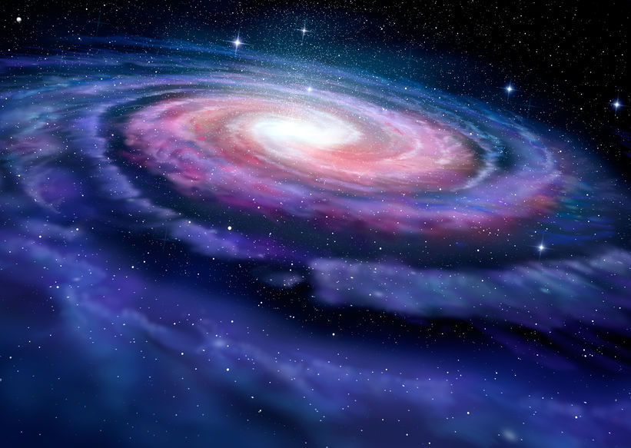
Spiral Galaxy. Image: alexmit

UNDERSTANDING THE TEXT:
Genesis 1 and 2 contain two separate accounts of the creation. Genesis 1:1-2:3 gives a generalized view of the story (rather like a photograph taken through a wide-angle lens) and Genesis 2:4-25 gives a more closely focused account like a photograph of the same scene taken through a close-up lens. Many scholars who have looked at these chapters think that they represent different stories coming from different sources (the documentary hypothesis mentioned in lesson one), but a number of the creation narratives of the ancient Near East followed the same pattern of introducing their story in a general way, then retelling it with different details.
As the Genesis creation story unfolds we find the earth and its creatures, humans, and key social and religious institutions described as being created in six days. With a clear logical structure not found in most ancient origin stories, in Genesis the first three days of creation describe God creating realms of habitation, while the second three days describe him creating the inhabitants of those realms.
Various theories have been proposed which suggest that there is a gap – perhaps of millions of years – between the first two verses of Genesis 1. According to one of these ideas, the world was created but was “formless and empty” for a long period of time as it developed through geological processes. A common argument for this view is that the word “created” (Hebrew bara) used in Genesis 1:1 is different from the normal word for “made” used in the Old Testament and implies God originally created the world and then much later “made” living things. But this argument overlooks the fact that the creation account also uses bara in Genesis 1:21 and 1:27 to describe the creation of the sea creatures and birds on the fifth day and of man and woman on the sixth day.
Alternately, it is sometimes said that the earth became formless and empty (the Hebrew word hayah translated “was” in “the earth was formless and empty” can also mean “became”) because of a great destruction resulting from the rebellion of Satan and some of the angels (based on one understanding of scriptures such as Isaiah 14:12–14). According to this view, what is recorded in the rest of Genesis 1 is the recreation of the earth’s surface. But there are many linguistic, logical, and biblical problems with this view, and it goes against the plain meaning of scriptures such as Exodus 20:11 which states that “In six days the Lord made the heavens and the earth, the sea, and all that is in them.”
We can learn an important principle from these theories: that it is better not to attempt to introduce ideas into the biblical text that are not clearly stated there. Ultimately, it is simpler, and better handling of the Scriptures, to accept biblical stories as they are rather than trying to force our own speculations into what the Bible says.

KEY THEOLOGICAL CONCEPTS:
While the creation stories of other cultures of the ancient world contained detailed descriptions of how their gods and goddesses came into existence, Genesis is unique in describing only one God – the concept of monotheism that has had immeasurable influence on the intellectual and moral development of the world. The word used in Genesis 1 for “God” (Hebrew Elohim) is a uni-plural noun (like fish) that can be singular or plural. Elohim is used of God and sometimes of angels, judges, and false gods. But when Elohim is used of God, it is used with singular verbs, showing that only one God is being discussed.

Similarly, although in Genesis 1:26 God says “Let us make mankind in our image,” this verse may simply mean that God was speaking to an audience of angelic or spiritual beings, or – from a Christian perspective – God the Father may have been speaking with the preincarnate God the Son who made all things (John 1:1-3). In any event, the unique monotheism of the Genesis creation account is clear and continually affirmed as Genesis progresses.
The creation story is also unique in that it is silent regarding God’s origins. Genesis clearly implies that God has no origins and exists outside of time. Genesis also shows that God exists outside of nature rather than being a part of it (which is why the existence of God cannot be scientifically proven, because science can only examine and “verify” that which is within nature). Genesis also shows that God created from nothing rather than making everything from preexisting material, as in all other known ancient creation accounts.
God’s first recorded words in the Scriptures are “Let there be light” and the precedence of light before all other created things is entirely unique to the Hebrew Bible, although many people find these words puzzling because light is mentioned as being created on the first day, while the sun, moon, and stars are said to not have been created until the fourth day. There are a number of plausible answers to this apparent difficulty – such as the possibility the Genesis account intends us to understand that the heavenly bodies were created when God made light appear (Genesis 1:1, 3), but they were not assigned their calendric purposes as markers of days and seasons until the fourth day of creation (Genesis 1:14-18), or that the sun, moon, and stars were created in verse 1 but were not visible from the surface of the earth until God cleared the cloud-filled skies in verse 14 – as discussed above. However, the various reasonings of this type all have weaknesses, and it is perhaps simply the case that the light appearing on the first day is intended to refer to light from God, just as the New Testament tells us that in the future heavenly city there will be no sun, but God himself will be its light (Revelation 21:23; 22:5).
Whatever the best explanation of this situation may be, there are two important results that proceed from the way the biblical creation story discusses light. First, Genesis makes it clear that the sun, moon, and stars are not deities as most of the ancient world believed, but that they are physical things created by God. This introduces a powerful statement against polytheism into the biblical story and an equally powerful elevation of the One True God. Second, the direct association of light with God is a theological statement developed throughout the Bible and one that tells us a great deal about the nature of God. The creation narrative would be vastly different if the origin of “light” had not been mentioned at the outset.
There are other unique aspects of Genesis 1 and 2 regarding the origins of aspects of biblical religion – such as the first commandment (for humans to have children), the first religious institution (that of the Sabbath rest from work), and the first use of the concept of “holiness” which is found in Genesis 2:3 (also in regard to the Sabbath day). All these concepts are implicit in the very opening chapters of the Hebrew Scriptures and are unique among the religious concepts of the ancient world.
A final important point is that Genesis 2:4 introduces a second name for God: Yahweh (see Note 1). The two names of God introduced in the creation story – Elohim and Yahweh – figure heavily in the documentary hypothesis, but there are many possible reasons for their use in Genesis as we will see as we progress through this course. Essentially, Elohim stresses the “transcendent” aspects of God’s nature outside of time and space (such as his eternal existence), and Yahweh stresses his “immanent” aspects within the world we know (such as his merciful kindness). The fact that both names are used together in a number of instances in the first chapters of Genesis, but rarely again in the rest of the Bible, shows the importance the creation stories placed on showing both sides of God’s nature.

Sunrise over the earth. Image: paulpaladin

* Note 1: In the Hebrew Bible this name is simply written with the four consonants YHVH. It is often pronounced “Yahweh” or “Yahveh” (and by some “Jehovah”), though it is not known exactly how it was originally pronounced. In English Bibles this name is usually translated “LORD” in all capital letters.

––
REVIEW AND REFLECTION: (complete in your notebook)
Basics: Summarize in a few words the three major ways of understanding the creation story. Think about the importance of trying to understand viewpoints other than our own to enable us to better share biblical knowledge and also to interact with other Christians.
What is described in Genesis as having been created in the first three days and second three days?
What are some unique aspects of the Genesis creation account as opposed to other creation stories of the time?
Looking Below the Surface: The apostle Paul wrote that “… ever since the world was created, people have seen the earth and sky. Through everything God made, they can clearly see his invisible qualities—his eternal power and divine nature…” (Romans 1:20 NLT). How many other aspects of God’s nature (his glory, love, etc.) do we see revealed in the creation story of Genesis 1-2?
Everyday Applications:
Genesis stresses the importance of light as the first aspect of creation, and light is said to be an attribute of God throughout the rest of the Bible. Think of a way in which your own life could better reflect light today and plan to accomplish that.
© Copyright CornerstoneCourses.org 2020. All rights reserved. This lesson unit is part of a free Cornerstone Bible Course and is not to be sold. Download the free course from CornerstoneCourses.org.

